**WHEN In Ansible**

First we will check which ansible_os_family our machine belong to :

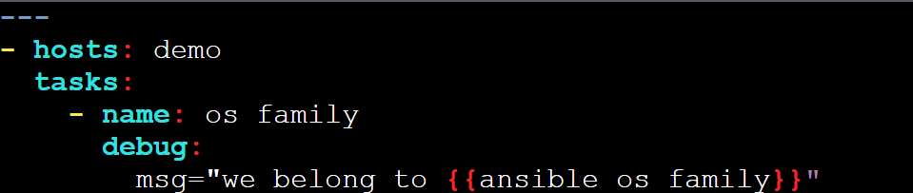

Now we will write playbook to demonstrate when statement

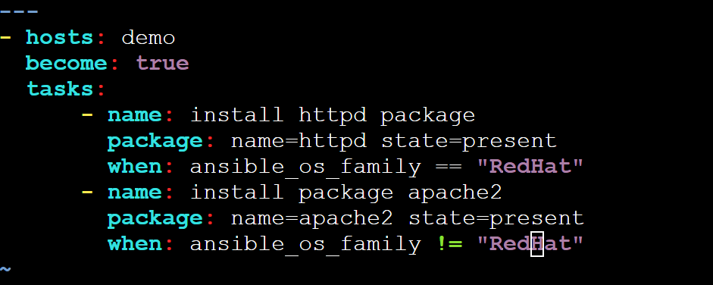

---

- hosts: demo

become: true

tasks:

- name: install httpd package

package: name=httpd state=present

when: ansible_os_family == "RedHat"

- name: install package apache2

package: name=apache2 state=present

when: ansible_os_family != "RedHat"

ansible-playbook whencon.yml

WHEN and and statement : when we need two conditions to be satisfied

If we want ansible distribution and ansible distribution major version condition to be satified

First lets check what ansible distribution and major version we using

vi checking.yml

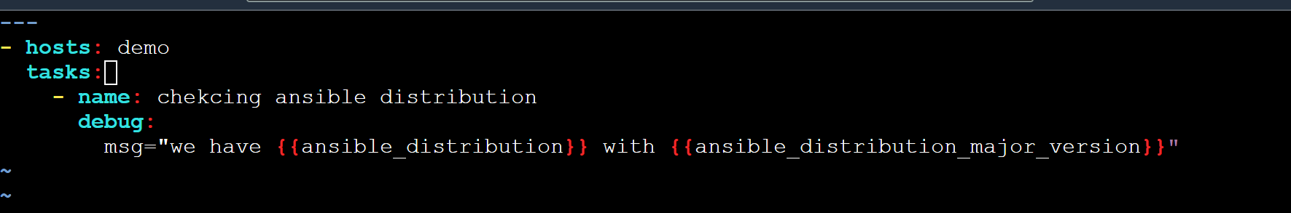

---

- hosts: demo

tasks:

- name: chekcing ansible distribution

debug:

msg="we have {{ansible_distribution}} with {{ansible_distribution_major_version}}"

Ansible-playbook checking.yml

o/p:

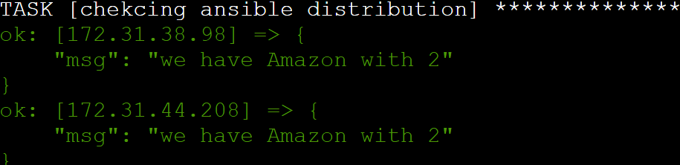

Lets write the yaml file with **when** with **and** condition

Vi whenwithand.yml

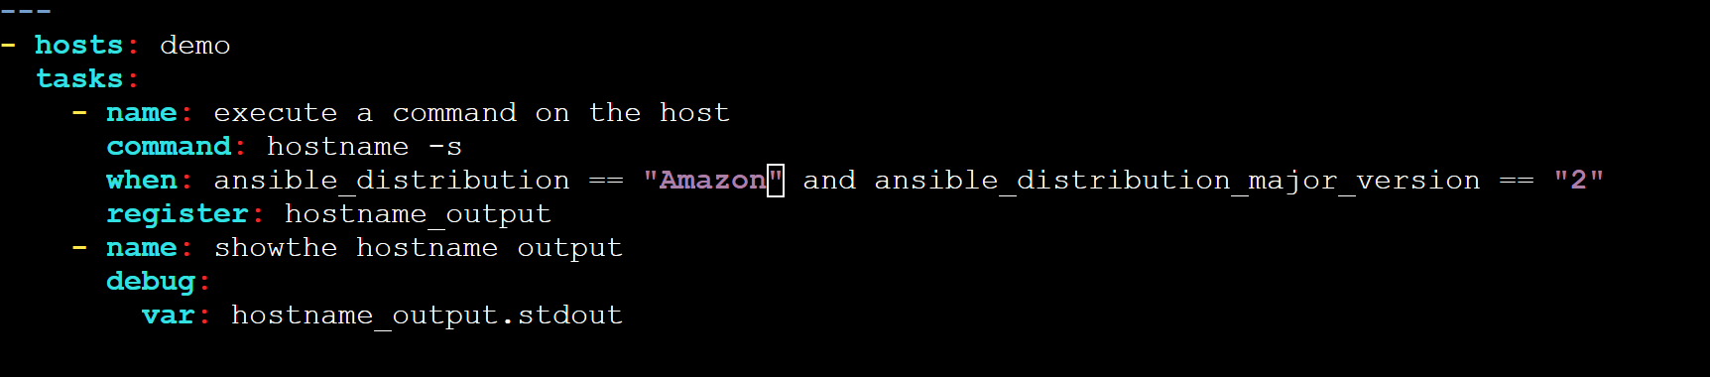

Here you can see two condition need to be satified otherwise the output would be skipped

In above the output of hostname is saved as hostname_output and then it is printed in the second task

---

- hosts: demo

tasks:

- name: execute a command on the host

command: hostname -s

when: ansible_distribution == "Amazon" and ansible_distribution_major_version == "2"

register: hostname_output

- name: showthe hostname output

debug:

var: hostname_output.stdout

